**Introduction to Networking**

**OSI Model**

1. Identify the address class (Whether it’s class A/B/C) of the following IP addresses.
   1. 192.168.1.15

Ans:

* 1. 110.16.1.15

Ans:

* 1. 16.196.128.50

Ans:

* 1. 17.192.1.15

Ans:

* 1. 150.156.10.10

Ans:

* 1. 250.10.24.96

Ans:

* 1. 16.180.127.49

Ans:

* 1. 172.156.1.15

Ans:

* 1. 17.196.128.50

Ans:

* 1. 156.150.10.15

Ans:

* 1. 167.68.1.15

Ans:

* 1. 200.58.20.165

Ans:

* 1. 167.128.23.15

Ans:

* 1. 167.168.1.15

Ans:

* 1. 192.173.15.10

Ans:

1. Identify the Network ID and Host ID for the following IP addresses
   1. 192.168.1.15

Ans:

* 1. 110.16.1.15

Ans:

* 1. 16.196.128.50

Ans:

* 1. 17.192.1.15

Ans:

* 1. 150.156.10.10

Ans:

* 1. 200.10.24.96

Ans:

* 1. 16.180.127.49

Ans:

* 1. 172.156.1.15

Ans:

* 1. 17.196.128.50

Ans:

* 1. 156.150.10.15

Ans:

* 1. 167.68.1.15

Ans:

* 1. 200.58.20.165

Ans:

* 1. 167.128.23.15

Ans:

* 1. 167.168.1.15

Ans:

* 1. 192.173.15.10

Ans:

1. Watch the you tube link and create a network like the following:

<https://www.youtube.com/watch?v=q-UUbPk6fYo>

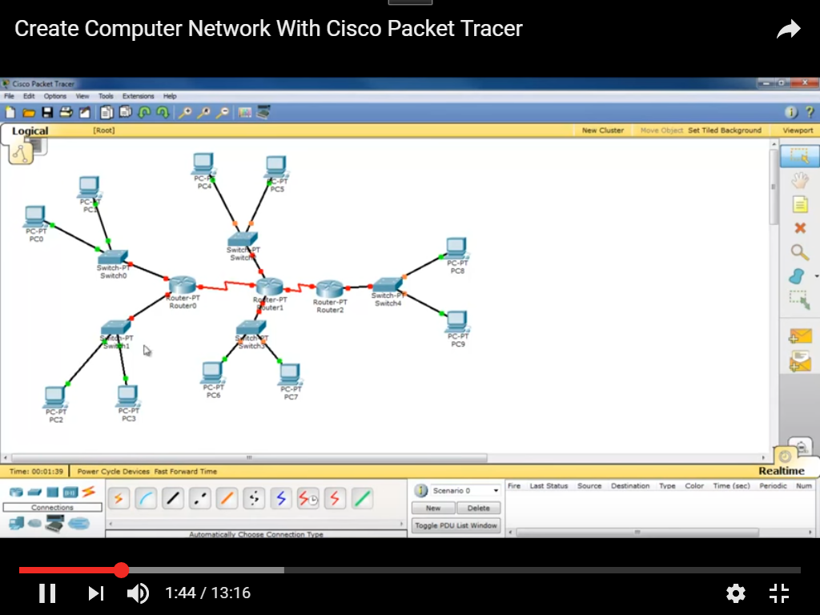

After creating the network fill up the following table with PC’s (All) IP Address, Router’s (All) IP Address & Switches IP Address (if any)

|  |  |
| --- | --- |
| Devices(PCs, Routers&Switches) | IP Address |
|  |  |